Gallaudet University

Solar Panel Project

Submitted by:

Dylan, Larry, David, Elina, and Mbisana

Submitted on:

November 9, 2021

**Abstract and Specific Aims**

Solar Panels at Gallaudet University group project’s goal is to find data and prove why solar panels are beneficial for Gallaudet University. Solar panels are becoming more popular for houses and schools to install on their roofs or around the campus. It will help benefits in the long term. We researched and found many universities use solar panels to benefit their cost of electricity. Gallaudet University could do the same thing. They are already in the process of installing solar panels on the campus for the community around Gallaudet University campus. We need to see data from our installation and show Gallaudet University that does benefit from electricity.

**Background**

Gallaudet needs more diversity for energy sources. They already have some things so solar panels can be additional. The solar panels' tools were struggling to find the data, so we contacted the solar panel companies in DC to help us find the best way to get the data. It will help us to calculate and find the data for our project to show Gallaudet University.The issue is that Gallaudet don’t have their own solar panels to save electricity and money to benefit their own. Storage batteries can charge during peak generation and provide a trickle of power at night, but they can be expensive, contain toxic materials and wear out quickly due to repeated charge and discharge cycles. Solar panels need to be installed to save money. Don’t have to rely on oil or another for use electricity. Our plan is to figure out what size space on the WAB roof that can fit how big solar panels and how many then calculate how much energy collected to fit WAB energy usage in a day. The data collected will be able to help know how much would be saved and how big or small solar panels needed to be installed. Also, This research is increasing power collection efficiency by developing a device that tracks the sun to keep the panel at a right angle. The tracker is designed employing the new principle of using small solar cells to function as self-adjusting light sensors and also providing a variable stimulation of their relative angle to the sun by detecting their voltage output. The result of the power increasing over a fixed horizontal array by 30% [5].

**Preliminary Results**

We collect the information of the WAB building area and how much space that can be installed on the WAB building. We collected data of the electricity usage in WAB from 2016 to 2019. We will be able to calculate the data with the space of the WAB roof that has a possible installed amount of solar panel and see how much energy will reduce the cost of electricity bill for WAB. This data does not include electricity used to cool the building since it comes from the University’s central plant. In the article [6], a group of people who analyze solar panels how much the university will profit. They calculate and claim university will profit 50 euros each month which means through the years university will earn a lot of money. According to the article [5], the advantage is to sell the power to the state, solar panels are safe, and nothing really risks it. If you have consumption of 200-400 kW / h per month you will benefit from installation of solar panels in the average total.

|  |  |  |  |  |  |  |  |  |  |  |  |  |  |
| --- | --- | --- | --- | --- | --- | --- | --- | --- | --- | --- | --- | --- | --- |
|  | | **Months** | | | | | | | | | | | |
| **January** | **February** | **March** | **April** | **May** | **June** | **July** | **August** | **September** | **October** | **November** | **December** |
| **Years** | **2016** | 36.22 | 31.34 | 29.65 | 33.52 | 28.46 | 30.61 | 33.8 | 34.25 | 33.11 | 34.26 | 31.79 | 31.84 |
| **2017** | 30.39 | 30.96 | 30.71 | 32.8 | 30.85 | 32.17 | 34.22 | 34.08 | 35.53 | 35.02 | 36.19 | 36.99 |
| **2018** | 37.52 | 33.01 | 3.92 | 0 | 0 | 0 | 6.12 | 30.72 | 32.93 | 34.3 | 34.26 | 32.13 |
| **2019** | 28.65 | 33.6 | 29.36 | 31.38 | 30.93 | 37.59 | 35.96 | 32.27 | 31.35 |  |  |  |

**Figure 1.** *Graph of months and years for average watts*

Figure 1 shows the average watts taken every month each year from 2016 to 2019. We noticed that no data was collected in 2018 from April to June and also there is missing data in 2019 from October to December which will affect our results. Also, we noticed that there may be a mistake in 2018 in March and July because the data is too low and different from the total average of each month.

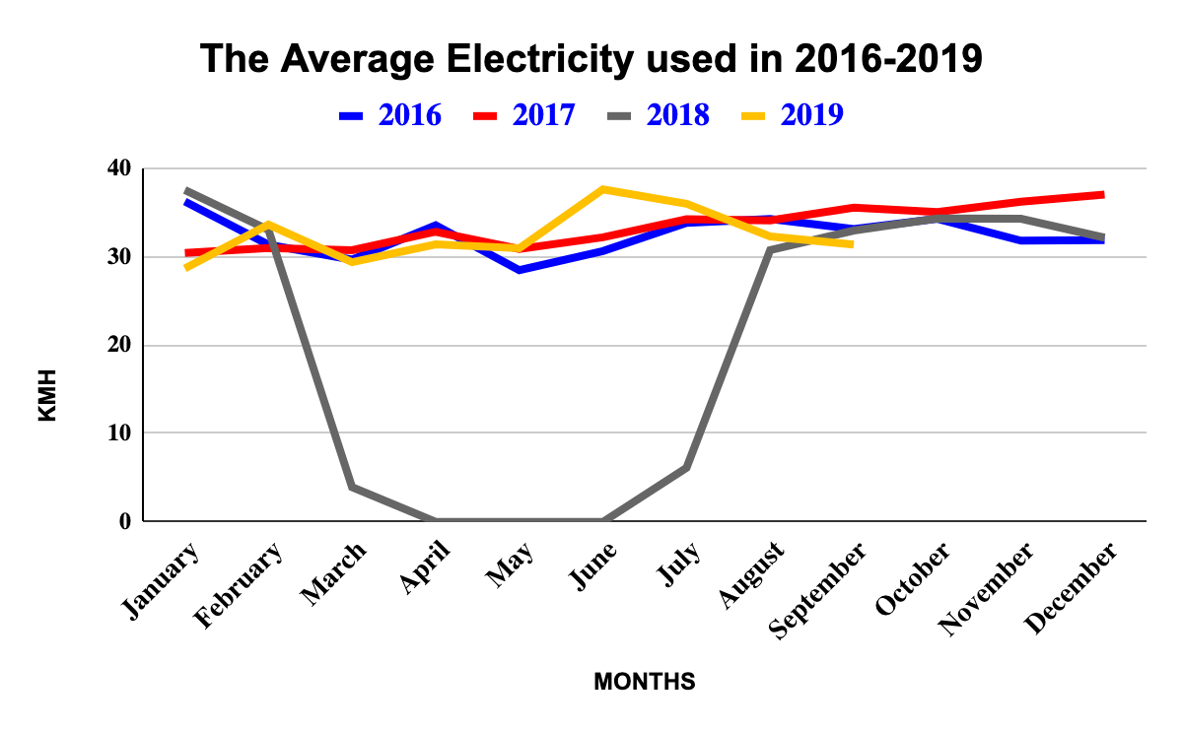

**Figure 2.** *Line graph shows years and months to see how many KMH.*

Figure 2 shows a linear graph showing the visual data of watts used every month of each year from 2016 to 2019. We noticed that the electricity used in 2016 is low compared to the one used in 2017, as we can see on the graph that the linear of the year 2016 rises and overlaps linear 2017 between February to April then its start increases till the end of the year. The linear 2018 could not be compared with others because the mistakes and missing data between March to July affects our results. The linear 2019 data shows that the electricity used rises higher twice between January to February and May to June.

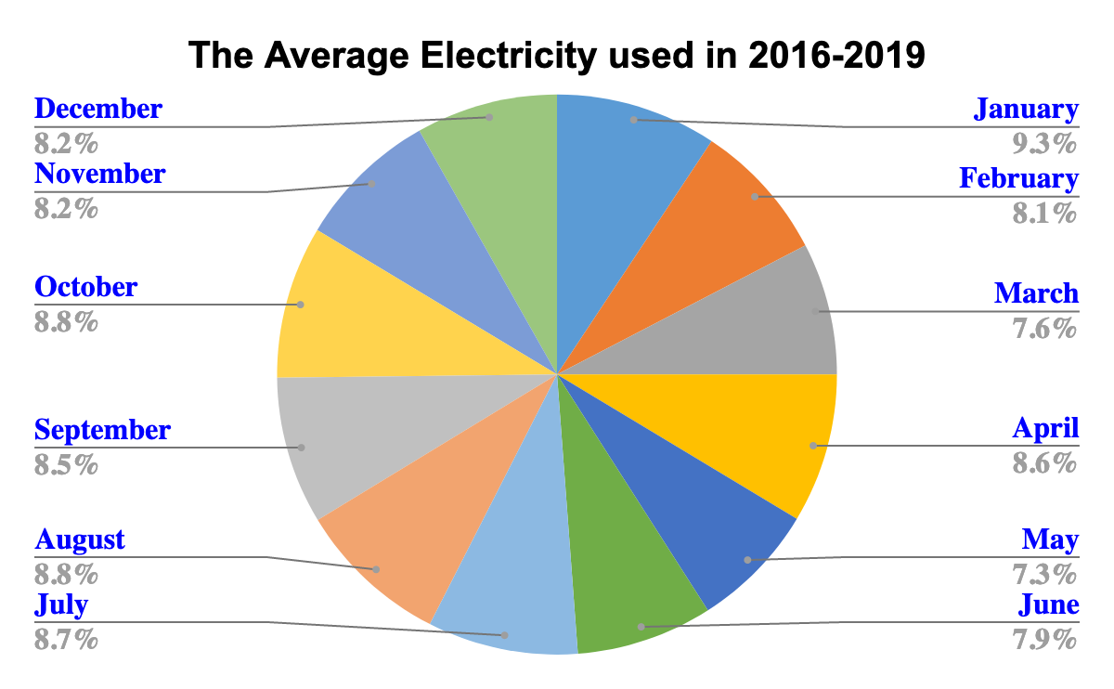

**Figure 3.** *Pie graph shows average electricity used in each month in four years.*

Figure 3 shows the Pie graph of the electricity used in each month for four years in percentage. We noticed that the highest electricity used is in January which takes 9.3% of a pie chart then followed by October and August both with 8.8% in a pie chart. The latest month using low electricity is May with 7.3% in the pie chart, followed by March with 7.6% and June with 7.9% in the pie chart.

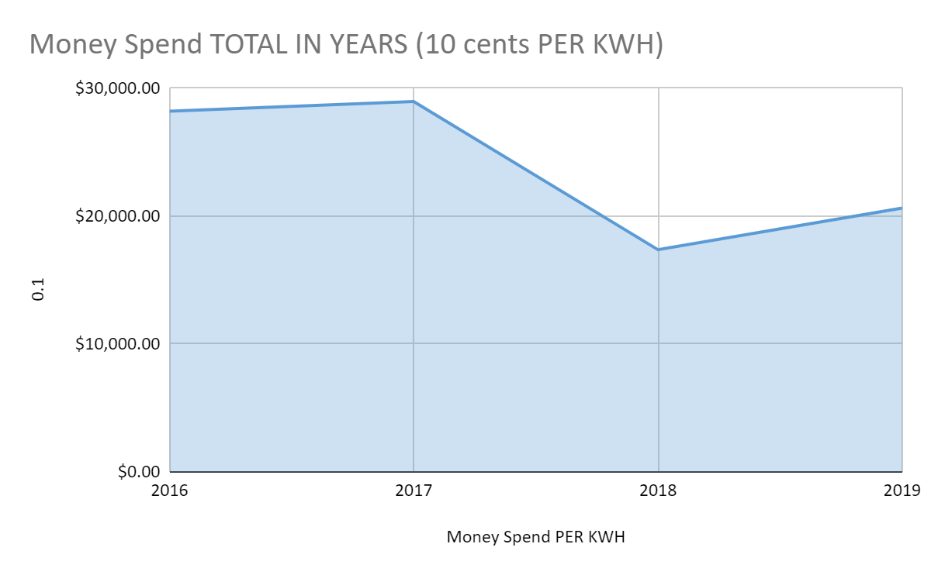

**Figure 4.** *Money Spends Electricity in Year Total*

As you can see from the graph, we can see how a gallaudet spends electricity at the WAB building per year. In 2016, Gallaudet had to spend $28,202.60. Then 2017, $28,960 which was increased. In 2018, Spends $17,378.78 which is a lot of missing data which wasn't counted. Then at last, in 2019, spends $20,627.39. It was only from January to September that was counted from data I received.

**Research Design**

Our research shows how solar panels impact universities in several ways and see what positive and negative outcomes to installed solar panels. We plan to install solar panels on WAB or on the grass field near WAB. However, if the solar panel is an issue to find so we use article [4] Boston College strategies to find data electricity usage with space for solar panels will cover the roof. To do that, calculate the total possible earnings that will cover electricity usage and how much profit will WAB building get in future.

The WAB buildings have predominantly fluorescent lighting fixtures. Fluorescent lighting fixtures is a low-pressure mercury-vapor gas-discharge lamp that uses fluorescence to produce visible light. An electric current in the gas excites mercury vapor, which produces short-wave ultraviolet light that then causes a phosphor coating on the inside of the lamp to glow. Fluorescent lamps, including compact fluorescent lights (CFLs), use about 75 percent less energy than incandescent bulbs and last six to 15 times as long, according to the U.S. Department of Energy (DOE). [2]

Fluorescent Lighting fixtures are usually used to provide illumination for settings such as commercial lighting, industrial lighting, classroom lighting, and retail lighting.

**Budget**

We will need to get measurements of the WAB roof that allow us to find the best possible Solar Panels including size that can fit the roof that come with cost. That is where we will need to pay for solar panels. In the future we will get benefits from it by reducing the electricity bill by solar panel use in WAB then use that money to pay off solar panel costs.

The budget that costs from electricity is approximately ten cents per kWh. We have approximately 200-400 kwh. Therefore, the electricity costs around ($20-40?) per month.

A website explains the four benefits of solar panels in homes. But three benefits that can be applied to Universities. First is to reduce the electricity energy bill. Second, earning the tax credits will save $7,500 solar system worth of $25,000. Last, that will help us and the environment by cleaning the air and will reduce dependence on fossil fuel. [3]

**References**

[1] Boldyrev, А. А., & Herasymenko, N. V. (2020). *The usage of solar panels advantages and disadvantages* (Doctoral dissertation, ВНТУ).

[2] Castro, Joseph. “Does Leaving Fluorescent Lights on Save Energy?” *LiveScience*, Joseph Castro, 26 July 2013, https://www.livescience.com/38355-fluorescent-lights-save-energy.html#:~:text=Fluorescent%20lamps%2C%20including%20compact%20fluorescent,of%20energy%20to%20start%20up.&text=Otherwise%2C%20turn%20the%20light%20off.

[3] Holowka, T. (n.d.). *Top four benefits of installing solar panels on your home*. U.S. Green Building Council. Retrieved October 27, 2021, from https://www.usgbc.org/articles/top-four-benefits-installing-solar-panels-your-home.

[4] Meyer, A., Zaman, F., & Norton, E. (2014, April 1). A Case Study: Solar Panels at Boston College. Chestnut Hill; https://www.bc.edu/content/dam/files/schools/cas_sites/envstudies/pdf/Student%20Research/8_Solar_Panels_at_Boston%20College_paper.pdf.

[5] Rizk, J., & Chaiko, Y. (2008). Solar Tracking System: More Efficient Use of Solar Panels. Retrieved October 26, 2021, fromhttp://citeseerx.ist.psu.edu/viewdoc/download?doi=10.1.1.306.7087&rep=rep1&type=pdf

[6] Saitov, E. B., Toshov, J. B., Pulatov, A. O., Botirov, B. M., & Kurbanov, Y. M. (2020). Networked interactive solar panels over the roof photovoltaic system (PVS) and its cost analysis at Tashkent State Technical University. In *E3S Web of Conferences* (Vol. 216, p.01133). EDP Sciences.